<http://yaseenabdel-hamid.gpro.apstudent.be/cms-intro/wordpress-01/wp-admin/options-reading.php>

OEF1

OEF 2

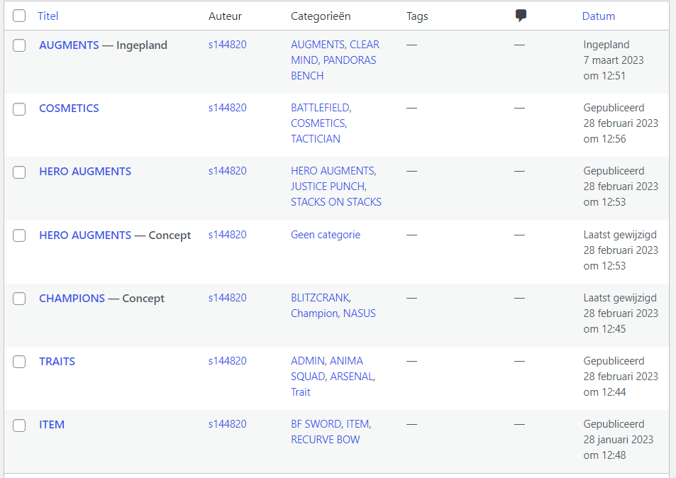

OEF 3

OEF 4

OEF 5

